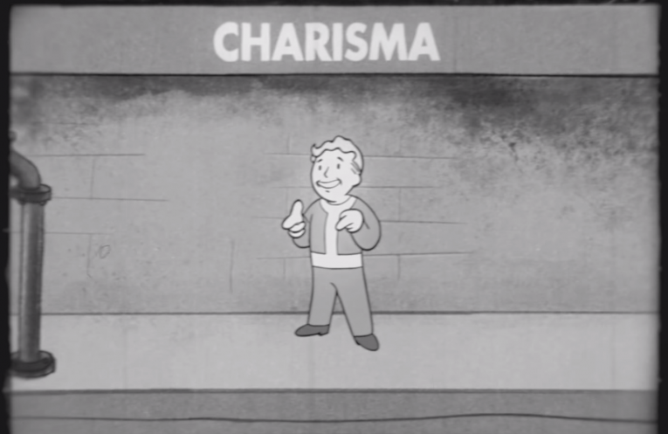PROG 02: Represent!

[Demo video](https://youtu.be/qoJdMNw2Fdg)

[GitHub repository](https://github.com/cs160-sp16/prog-02-represent-maguerrieri)

# Screenshots

|  |  |
| --- | --- |
| Main screen: | Representative details: selecting a location opens the list, and tapping the three-dot “more” button opens the detail view. The web and email icons open the system browser or mail sheet to that representative’s address. |

# Changes from Original design

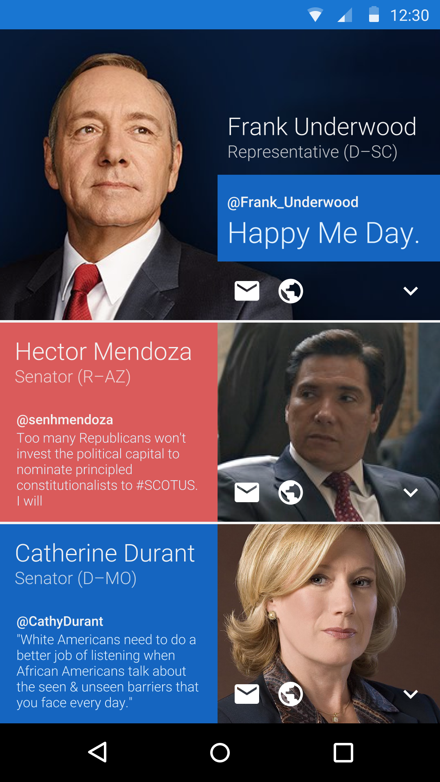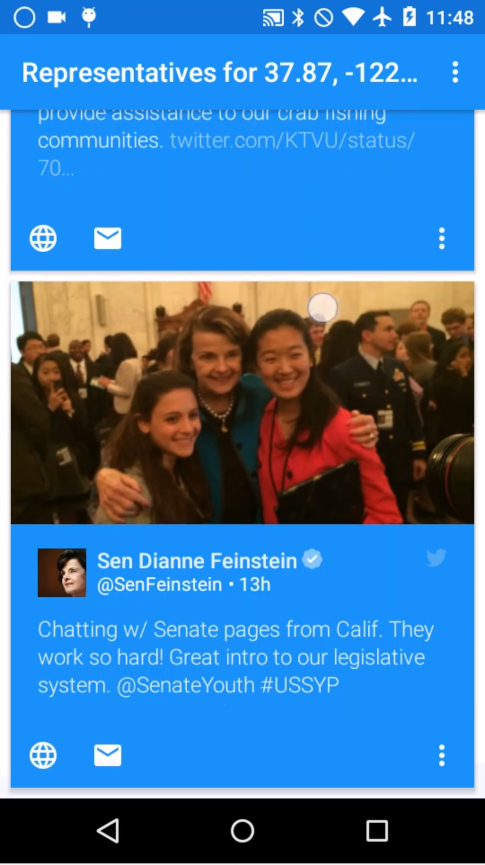

The list view changed the most compared to my original design. I gave up on the static three-person view when I realized how common it would be for more than one representative to turn up in a query. Laying out each tile identically and scrolling them was much easier to implement, and still looks and feels nice.